**Routes For The Bird Route:**

storyline1

The bird laying next to you was freaking out by you giving her a cigarette. She took it and flew away without saying anything to you. Guess that is to say that no good deed goes unpunished. You could really stick your beak into a Monster Energy Drink or a Redbull right now so you hop out of the dumpster that you sleep in and waddle into the gas station. You see Bucky Adams loiter in front of the gas station. Once again, he is muttering to himself. What do you do?

**Bucky Adams Decisions:**

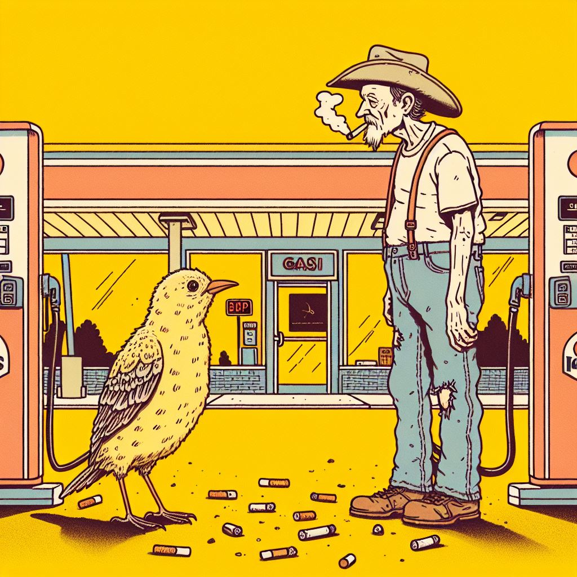

**(if you peck Bucky Adams)**

"'Ow! That smarts!' Bucky Adams said as you pecked him. 'Alright! Alright! I'll get out of the way!' He shakes his fist in the air for some reason, even though you are at foot level. Upon realization, you see that he’s wearing sandals. A zombie invasion is about to happen, and the guy is wearing sandals. But hey, I’m not the one to judge. You stammer into the gas station. It's quite busy. A lot of people are buying snack food and beer for the incoming zombie invasion. In moments like these, you’re glad you're a bird and that your diet consists of just worms and bugs. You waltz into the gas station. Everyone stares at you as if you were a freak. You bump into a family of four in the chip aisle. What do you do?

Here’s a polished version:

"Thanks for the cig! It’s not every day a bird bums me a cigarette. That’s so cool. I didn’t even know they made birds like that. You know what would be even cooler? If there was a bird trained to give *two* cigarettes. I’d just about explode with excitement if that ever happened to me. Anyway, thanks. You’re really cool."

That was Bucky Adams. He always seems happy.

The idea of a bird giving *two* cigarettes lingers in your mind—what a concept.

You waltz into the gas station. Everyone is staring at your friend, Bucky Adams. He had just celebrated one year of being cigarette-free—until now.

You bump into a family of four in the chip aisle.

What do you do?

**Family Decisions:**

**(if you offer the family 1 or 2 cigarettes)**

As you extend your wing out to offer them a cigarette, you realize that they are actually a family of undercover zombies! They snag your wing with their teeth. Ouch! Your screaming alarms the nearby person who was scoping out the aisle for some peanuts. Oh, thank goodness, the fella in the other aisle just happened to be an FBI agent. He says, "Ah gee, that was a close one, wouldn't you say?" And, of course, he is wearing aviators. What sort of FBI agent *isn't* wearing aviators? What do you do?

**2 cigs**

As you extend your wing to offer them two cigarettes, you suddenly realize that they’re actually a family of undercover zombies! In a flash, they lunge and snag your wing with their teeth. Ouch! Your screams echo through the store, catching the attention of someone in the next aisle who had been browsing for peanuts. Thankfully, the person turns out to be an FBI agent. He looks over at you and says, "Well, that was a close one, wouldn't you say?"

**(if you peck the family)**

You peck at the child, which causes all of them to hunch on the floor and scream. What the heck? They’re zombies! Your pecking broke their disguise! Their screeching alerts everyone in the gas station. No one has ever considered the paradigm or possibility that zombies could infiltrate the modern fabric of society this easily. Everyone’s knowledge of zombies has been shaped by Hollywood, but in reality, zombies are much more subversive and pervasive. But you did a real good job pecking that family. As a result of your pecking, the entire gas station has now been introduced to the enemy that is about to befall them. The fella in the other aisle walks over to you, looks down at you, and gives you a fist bump. You believe he’s an FBI agent because the back of his jacket says "FBI" in big yellow letters. He says, "You sure showed those zombies who’s boss." He laughs at his own comment like it was the funniest punchline ever. What do you do?

**FBI Decisions:**

**(if you offer 1 cig to the FBI Agent)**

"Thanks! I love candy!" The FBI agent eats the cigarette.

Has he never seen a cigarette before? Odd. I mean, I guess the purpose of a cigarette isn’t exactly intuitive, but I would’ve thought an FBI agent of all people would know how cigarettes work. Am I alone in thinking that? I don’t want to come off as too harsh here. The FBI agent thanks you, but you can tell from his constant spitting on the floor that he’s just being polite. Good for him. He runs off into the gas station bathroom.

**(if you offer 2 cigs to the FBI Agent)**

The FBI agent grabs both cigarettes and eats them. Has he never seen a cigarette before? Odd. I mean, the purpose of a cigarette isn't exactly intuitive, but you'd think an FBI agent would know how they work. Maybe giving him two at once threw him off. Either way, you’ve just wasted a cigarette. The agent looks like he’s about to puke, and in a panic, he scrambles out of the store, disappearing from view. Probably for the better—if the next FBI agent you encounter is him, you're in trouble.

Soon after, a janitor with the name tag "Darcy" watches you walk past the soda machine. What do you do?

**(if you peck the FBI Agent)**

"Those are some gnarly moves!" The FBI agent yells in a voice that is most definitely not an inside voice. "I can do better!" He starts pecking at you—much better than you can peck him, actually. The FBI agent squats on his knees and aggressively starts pecking at you. You get ruffled up a bit. Thankfully, this is more embarrassing for him than for you, because you’re a nameless bird who doesn’t have much standing in the world—at least not compared to the FBI, who is pelting his lips on you. You become more conscious of your own pecking ability, and now you can "peck" people twice. You leave the FBI agent, never to see him again, because, thanks to his "playful affection" with you, he has now contracted bird flu. A very potent strain, since your home is the back dumpster. Dumpster Bird Flu. Oh goodness, I wouldn’t wish that upon my worst enemy. But at least you learned how to peck things twice now.

Soon, a janitor with the name tag "Darcy" watches you walk by the soda machine. What do you do?

**Janitor Decisions:**

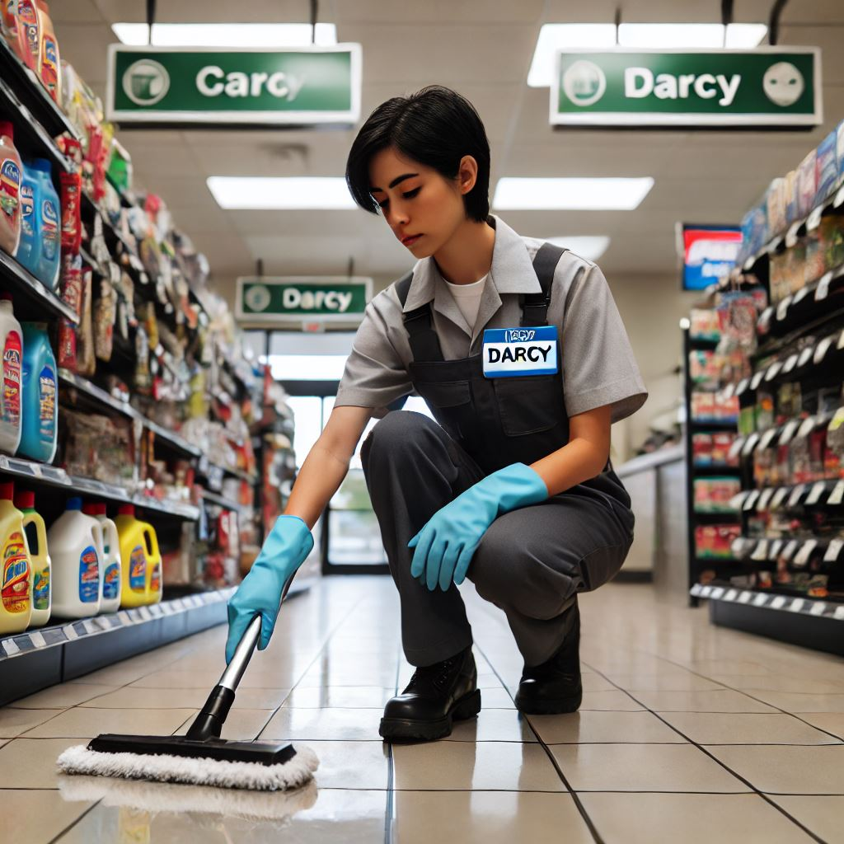

**(if you give the janitor a cigarette)**

“You’re too kind!" The janitor places the cigarette in his pocket. “I am going to enjoy this bad baby later. I won’t tell anyone that you are in here. Birds deserve to loiter in gas stations as much as everyone else. Once again, thank you for giving me, a humble young child like me, a cigarette. Now, please allow me to make sure this gas station is pristine. You motivated me to stop being so lazy! **The janitor stays inside.** A stray cat lingers into the gas station. Meowing and hissing. Uh oh. It’s hungry and you are the most appetizing thing in the gas station. What do you do?

**(if you give the janitor 2 cigarettes)** This unlocks 1/4 of the conditions for the true ending.

"Wow, not many people give me cigarettes because I’m only 14," the janitor says with a grin. "Thanks!" He sets down his mop and lets you hop up onto his arm. "I’m Darcy, by the way. I’m in 8th grade. I really wish I didn’t have to work at this dumb gas station. Did you see the news? A zombie apocalypse is about to hit, but here I am, still working. Hey, do you have any more cigarettes? Nah, never mind. You've given me enough. I'm gonna head outside and enjoy these bad boys. Hopefully, I won’t get mauled to death by zombies!" Darcy pats you on the head and gently sets you down. Suddenly, a black cat sniffs you. Holy cow, you didn’t sense that cat come in. A wet nose and twitching whiskers tickle your feathers. What do you do?

**(if you peck the janitor 1x)**

“What are you doing? Ow! What are you doing? Stop!” The janitor Darcy whacks you with his broom. Ouch. The janitor stays inside and returns to sweeping. “Pesky bird! Pesky, pesky bird!”

A stray cat lingers at the entrance of the gas station, meowing and hissing. Uh oh. It’s hungry, and you’re the most appetizing thing in the gas station. What do you do?

**(if you peck the janitor 2x)**

"That tickles! Ha, you're a funny bird. Stop pecking me! If you peck me one more time, I’m going to whack you with my mop. Thanks for not giving me any cigarettes, though. I see you've got ${cigarettesRemaining} left. I get really crazy if I have nicotine or whatever they call it. Who knows how I would’ve acted if you’d given me one—or even two!" He pauses, then shakes his head. "I should probably just abstain from smoking for the rest of my life. Imagine the dark timeline you just prevented by not giving me any cigarettes! Cigars? Maybe someday, though!"

What a weirdo. Darcy checks his watch. "Oh, it’s time for my break." With that, he leaves you behind, heading off for a well-deserved respite.

**Stray Cat Decisions (if Darcy stays inside):**

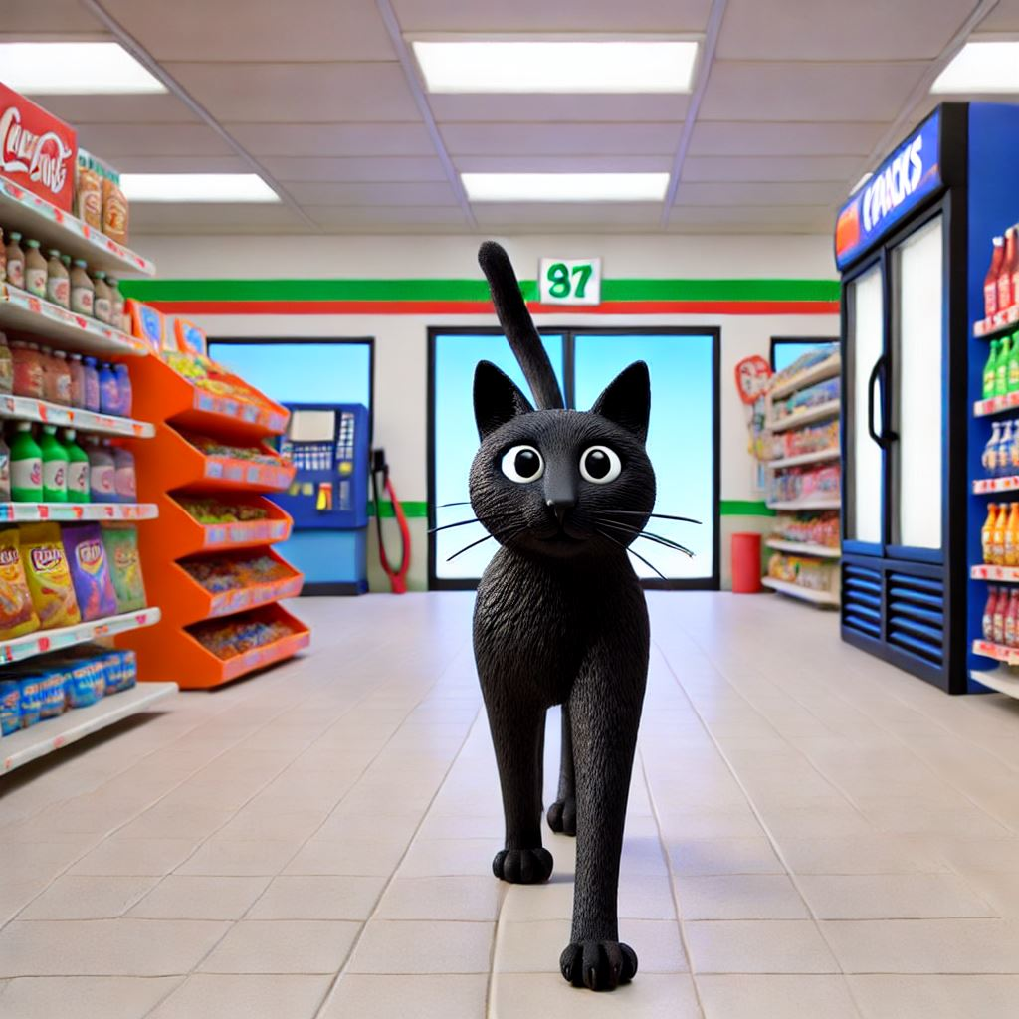

**(if you give the cat a cigarette)**

What are you doing? Why would you give that cat a cigarette? Are you trying to waste all your cigarettes? Nice survival instincts you got there. The cat swipes at you. Ouch. And it does it again. Super Ouch. Suddenly, a very large man with a dapper mustache screams. Everyone in the gas station looks at him. Well, well, well, it is Mr. Tabacco himself. What do you do?

**(if you give the cat 2 cigarettes)**

What are you doing? Why would you give that cat a cigarette, let alone two? Are you trying to waste all your cigarettes? Nice survival instincts you’ve got there. The cat swipes at you. Ouch. And it does it again. Super ouch. Did you know that outdoor cats kill an estimated 2.4 billion birds in the U.S. every year? That’s about 6.6 million birds a day, or nearly 274,000 birds per hour. And don’t think this is just the occasional bird—they target small songbirds, shorebirds, and even some species of endangered birds. It's been estimated that domestic cats kill 13.7 billion animals in total annually, including mammals and reptiles. So, yeah, this cat’s definitely not one to trust with your cigarettes. Suddenly, a very large man with a dapper mustache screams at the cashier, drawing everyone’s attention in the gas station. Well, well, well... it’s Mr. Tabacco himself. What do you do?

**(if you peck the cat 1x)**

You peck at the cat. It swipes at you hard. Ouch. You manage to fly away in time. The cat gives up on eating you and grabs a bag of peanuts from across the aisle. Suddenly, a very large man with a dapper mustache screams. Everyone in the gas station looks at him. Well, well, well, it’s Mr. Tabacco himself! What do you do?

**(if you peck the cat 2x)**

Good job. Your pecking really scares the cat away. Did you know that outdoor cats are disastrous towards typical bird populations. Way to stand up to yourself at a statistical disadvantage. As a reward, God gives you an extra cigarette for you to give out to people. Suddenly, a very large man with a dapper mustache screams. Everyone in the gas station looks at him. Well, well, well, it is Mr. Tabacco himself. What do you do?

**Mr. Tabacco Decisions (if Darcy stays inside):**

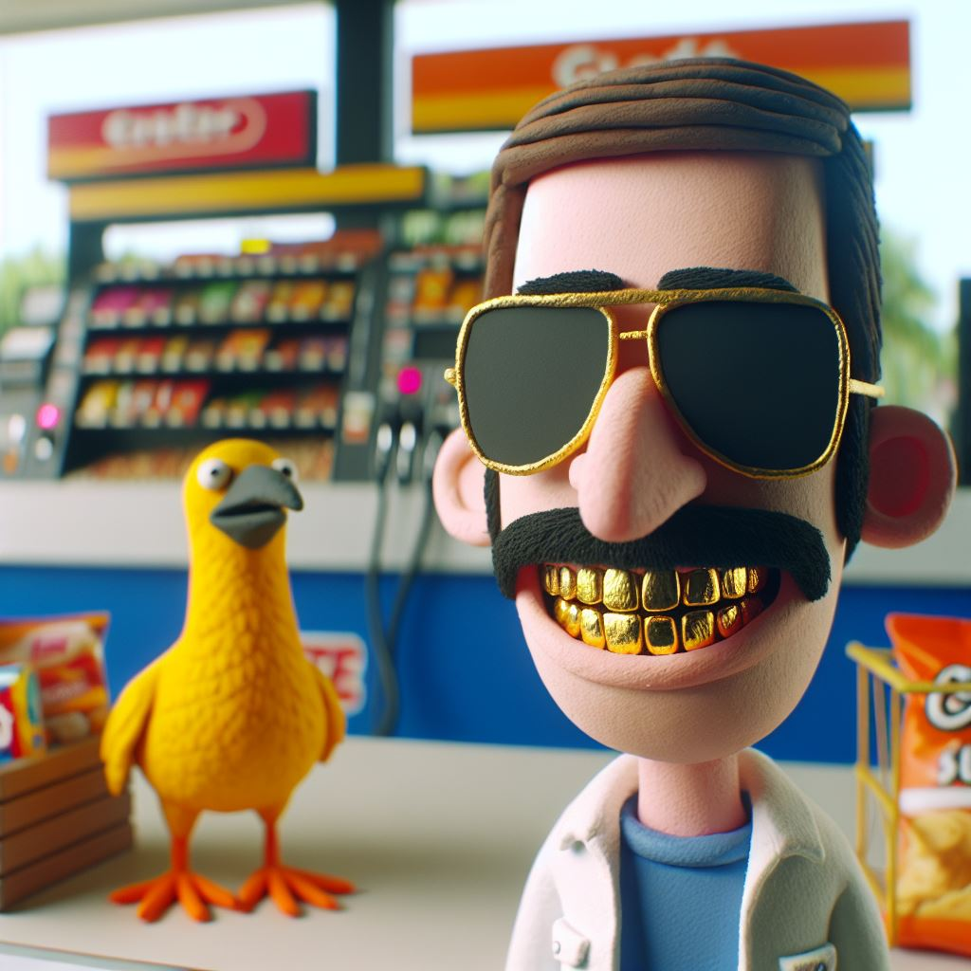

**(if you give Mr. Tabacco a cigarette)**

"Thanks." Mr. Tabacco lights the cigarette and shares it with the bird. The bird calms down.

You and Mr. Tabacco hang out.

"Even though you’re a bird, you’ve got pretty good vibes." Mr. Tabacco pushes up his million-dollar aviator sunglasses. "I heard there’s a zombie invasion going on. You seem cool. I’ll park my car here and help out wherever needed. We’ve got a bunch of… well, don’t worry about it. You’ll be set with my team around. Be sure to hunker down here. I hope everyone else here is as like-minded as you are, kind bird. Most people see that I’m the CEO of every cigarette company in the country and assume I have plenty of cigarettes on hand. But the truth is, I don’t. So thank you for your friendship. I’ll never forget this moment."

**(if you give Mr. Tabacco 2 cigarettes)**

Mr. Tabacco frowns at the bird, tosses the cigarettes into the trash, and immediately turns around, storming out of the gas station. "I hate brown-nosers," he mutters under his breath. Meanwhile, a guy decked out head to toe in camo stands at the checkout, buying a can of Pringles and about 40 cans of soup. He’s preparing for the incoming zombie invasion that’s about to wreck the entire city. What do you do?

**(if you peck Mr. Tabacco 1x)**

The second you start to peck at Mr. Tabacco, his security rushes in and pins you down. Once they realize that you’re just a bird, they let you go. They confiscate all your cigarettes. Nice going. Why would you peck at Mr. Tabacco?

A guy completely decked out in camo stands at the checkout, buying a can of Pringles and about 40 cans of soup to prepare for the incoming zombie invasion that is about to wreak havoc on the entire city. What do you do?

**(if you peck Mr. Tabacco 2x)**

The second you start to peck at Mr. Tabacco, his security comes in and pins you down. Once they realize that you are just a bird. They let you go. But Mr. Tabacco stops them.

“Hold on. This bird.”

“Who taught you that move? To peck me twice.”

He looks alarmed at his security team. “The FBI.” They all scramble.

“Look here, bird. I’m sorry for any damage my guys have done to you. We are all set now, correct?” Mr. Tabbaco gets on his knees and gives the bird a cracker. Restoring all of his HP to full.

A guy completely decked out in camo. He is at the check out buying a can of Pringles and about 40 cans of soup to prepare for the incoming zombie invasion that is about to wreck the entire city. What do you do?

**Zombie Prepper Decisions (if Darcy stays inside):**

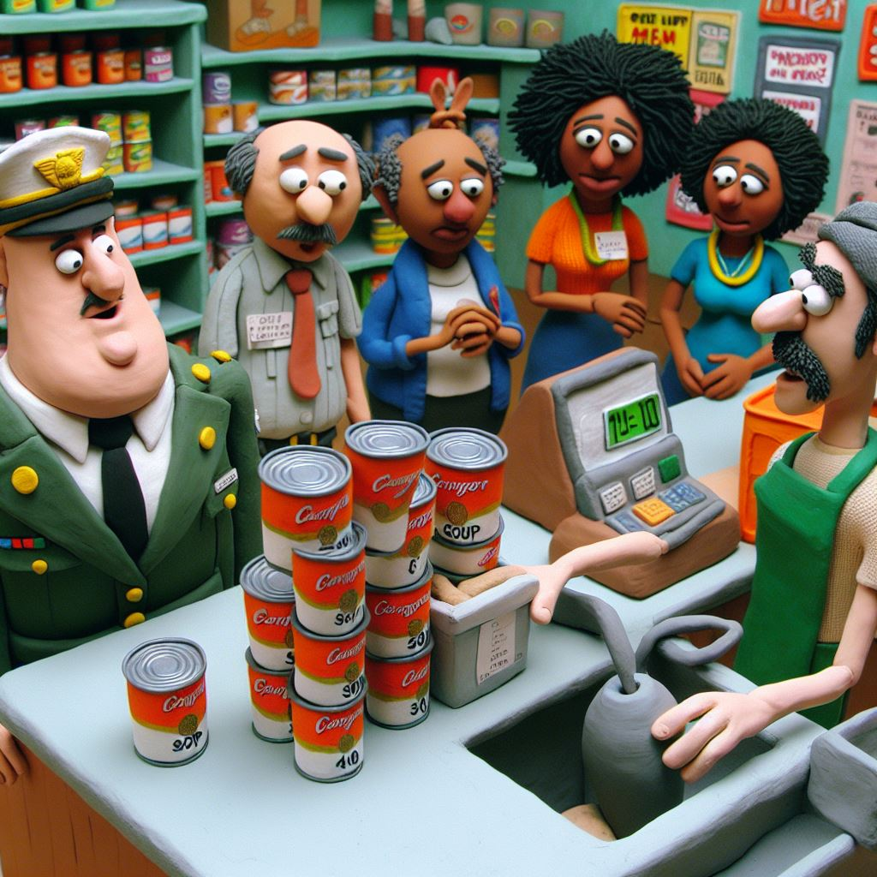

**(if you give the Zombie Prepper a cigarette)**

“Dude. Is this some sort of joke. This is my 4th year of quitting and you do this. I’m out of here.” The zombie prepper buys his can of Pringles™ and runs out of the store. He abruptly runs back in and kicks you. Ouch!

You can hear the incoming swarm of zombies crawl and moan. A foetor creeps fills into the gas station. The tension is palpable. You hop into the next aisle and you see Mr. Heart, the gas station’s mascot, dance and cheer, oblivious to impending doom.

**(if you give Zombie Prepper 2 cigarettes)**

"Dude. Is this some kind of joke? This is my 4th year of quitting, and you do this... Fine. We are having a zombie invasion, after all." The Zombie Prepper stands outside the gas station, joined by Bucky Adams. They talk for a while, deep in a philosophical conversation. But since you're a bird, you really couldn’t care less about any of that.

You can hear the incoming swarm of zombies, their crawling and moaning growing louder. A foetor creeps into the gas station, the smell thick and suffocating. The tension is palpable. You hop into the next aisle and spot Mr. Heart, the gas station’s mascot, dancing and cheering, blissfully unaware of the impending doom. What do you do?

**(if you peck the Zombie Prepper 1x)**

The doomsday prepper breaks down crying. Not even I, the omnipresent narrator, can explain why. He leaves the gas station, abandoning all those cans of soup and Pringles at the checkout lane. I suppose it’s yours to enjoy now. You recover a bit of health points. The clerk and you exchange a glance and shrug. Whatever. The food is now dispersed for all to enjoy. What a treat!

You can hear the incoming swarm of zombies crawl and moan. A foul stench fills the gas station. The tension is palpable. You hop into the next aisle and see Mr. Heart, the gas station’s mascot, dancing and cheering, oblivious to the impending doom.

**(if you peck the Zombie Prepper 2x)**

“What a cute little birdie you are!” The Zombie Prepper rubs his nose all over you for some reason and kisses you on the wings. Ack. He might regret doing that later, but for now, you provide him a sweet reprieve from whatever demons have been possessing him.

For some reason, a bass player starts strumming, and a trumpeter strides into the gas station.

“My guys are here. Finally. Hey, Louie Two-Times!”

The trumpeter stops mid-step.

“That here is my special buddy, Louie Two-Times. He just got out of the slammer, and now we’re gonna go fight some zombies, playa. Give this bird some C4. The little guy is gonna need it.”

The trumpeter hands you a whole bunch of C4. You can barely carry it on your wings. This may help later.

The air grows thick with tension as you hear the incoming swarm of zombies crawling and moaning. A foetor creeps into the gas station. The atmosphere is charged with dread. You hop into the next aisle, only to spot Mr. Heart, the gas station’s mascot, still dancing and cheering, blissfully unaware of the impending doom.

**Mr. Heart (happens after Mr. ATM or Zombie Prepper):**

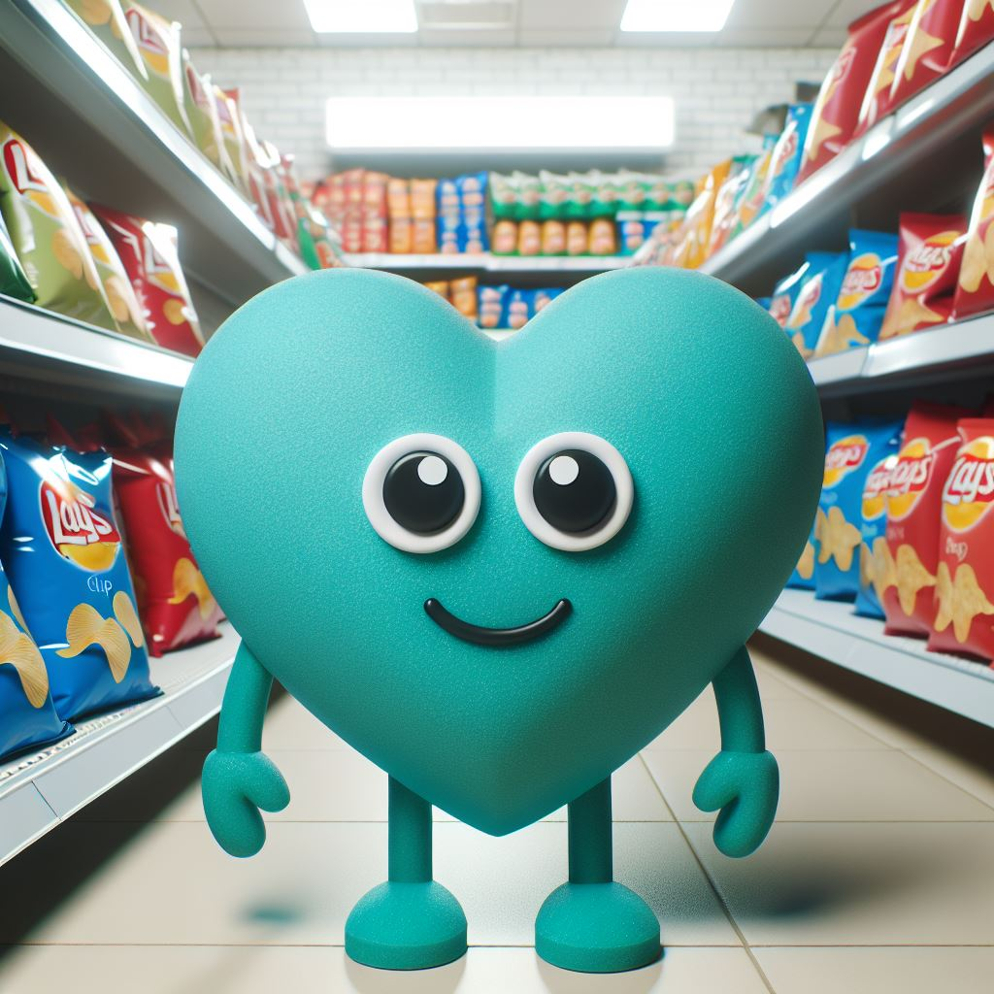

**(if you give Mr. Heart a cigarette)**

“I would prefer it if you left my store. You are but a stranger to me, and I to you. Why, then, would I accept these cigarettes from you?” Mr. Heart beats his chest with a single, slow motion, his gaze cold and piercing as he points to the exit.

Inside the fridge, you hear Bucky speak over the intercom. “Attention customers, the zombies have taken control of the streets. Everyone still in the gas station, we will be handing out bats and hammers. Please, if you can find room in your heart, help us fend off this oncoming horde.”

**(if you give Mr. Heart 2 cigarettes)**

"Leave my store, right now," Mr. Heart says, "I saw you handing out cigarettes like they're candy. What’s your endgame here?" With a dramatic flourish, he points toward the exit, his gaze regal and unyielding. "Well, whatever it is, I don’t want to see it. Beat it, tweedy bird."

Without warning, Mr. Heart kicks you. Ouch!

Inside the fridge, Bucky’s voice crackles over the intercom, sharp and urgent. "Attention, customers. The zombies have taken control of the streets. For those of you still here, we will be handing out bats and hammers. Please, if you find room in your heart, help us fend off this impending horde."

**(if you peck Mr. Heart 1x)**

Here’s the proofread and revised version of your paragraph:

“Get out. I did not give you permission to touch me.” Mr. Heart’s cartoon voice devolves into a stern, grouchy, almost startling tenor. You really think Mr. Heart is about to attack you until you hear a voice over the intercom.

“Attention, customers. The zombies have taken control of the streets. Everyone left in the gas station, we will be handing out bats and hammers. Please, if you find room in your heart, help us fend off this oncoming horde.” Mr. Heart and you exchange glances.

“We will settle this later. For now, this is the pivotal moment—the one that will define everything. At least for me. Perhaps for you, it’s just another fleeting concern, because that’s the type of person…bird…you are. I don’t hate you for it. It’s in your nature, after all, to remain indifferent to the struggles of humans. But now, I beg you, bird—help us. Help us face the relentless tide of the undead. Do this, and maybe, just maybe, we stand a chance.”

A heavy silence hangs between you two. In that moment, something shifts—a silent understanding. For now, you are allies. Together, you walk toward the clerk at the cash register, your fate tied to the chaos unfolding outside.

**(if you peck Mr. Heart 2x)**

“GET OUT. GET OUT. DO NOT TOUCH ME!” Mr. Heart grabs you by your talons and throws you across the store. The clerk hops over his cash register and restrains Mr. Heart. The FBI agent from before steps out of the bathroom and drops his phone. It bounces across the floor.

“Mr. Heart. I have spent the entirety of my career looking for you.” The FBI agent and Mr. Heart brawl. You hide in the beer fridge waiting for the commotion to stop. The two take it outside and you never hear from them again.

Inside the fridge, you hear the gas station clerk speak over the intercom. “Attention customers, the zombies have taken control of the streets. Everyone who is left in the gas station, we will hand everyone bats and hammers. Please, if you find room, in your heart, please help us fend off this oncoming horde. You hop up onto the counter. Instead of chips and soda, there are hammers and clubs. What do you do?

**Gas Station Clerk Decisions:**

**(if you give the clerk a cigarette)**

“…Is this all that you can contribute? Okay then. Thanks I guess.” The clerk puts your “contribution” if you would even call it on the counter top and within seconds it rolls onto the ground. As the gas station patrons gear up for their incoming fight. No one looks in your direction. You feel like your presence won’t contribute to anything. That’s because it is true. But you’re a bird, no one suddenly expects you to do anything else I guess. The incoming zombie wave crawls forward. Let’s see how the gas station does.

**(if you give the clerk cigarettes)**

"Some of us could really use these to calm down," Bucky Adams mutters, his voice tinged with urgency. He lays out a plan of attack, and to your surprise, it involves *you*. Everyone is handed a hammer, readying themselves for the fight ahead. You, however, can’t really hold a weapon. But your cigarettes have provided an invaluable reprieve for the men and women who are about to face their destiny at that gas station.

As people prepare for combat, some of them nod in your direction, silently praying as they head toward the door. The weight of the moment settles in. This is it. The calm before the storm.

Suddenly, the incoming zombie wave crawls forward. Sinking their teeth into car tires and tearing at the gas pumps. Let’s see how the gas station does!

**(if you peck the clerk 1x)**

The clerk, startled by your sudden pecking, stumbles back, his focus completely shattered. The battle strategy, once carefully crafted, begins to unravel in the wake of your distraction. “Why is this bird still here? Can someone get him out?” he demands, frustration evident in his voice.

Well done. You’ve managed to pull everyone's attention away from the task at hand, wasting precious moments that could have been used to prepare for the impending chaos. The seconds tick away, each one heavier than the last. Now, with the gas station in disarray, the true test begins: how will they fare against the oncoming zombie horde?

Suddenly, the incoming zombie wave crawls forward. The entire gas station feels pretty nervous. Their hands shaking as the zombies sink their teeth into car tires and tearing at the gas pumps. Let’s see how they do!

**(if you peck the clerk 2x)**

Everyone laughs and smiles as you peck the clerk’s hand two times. The tension melts away, and the mood lightens, as people become less stressed about the zombie invasion. You flutter around the gas station, pecking everyone as they prepare for combat. One guy starts crying. Sheesh, take it down a notch. But aside from that, everyone is suiting up for the fight.

“Let’s get going!” the clerk shouts, rallying the group.

Bucky Adams pumps his fist in the air, ready for action. Darcy wields his mop like a true warrior, determined to defend the station. And as for you? Well, all you can do is fly and watch—after all, you’re just a bird. No offense.

The battle is about to begin, but how will it all end?

Bucky Adams spots the zombies coming from a mile away. the incoming zombie wave crawls forward. Everyone gears up and even gets warmed up to bash some zombie heads. Let’s see how they do!

**Zombie Invasion Time:**

If power ranking is too low and you have more than 1 cigarette=>

The zombies stampede into the gas station. Doesn’t help that Bucky Adams forgot to barricade the automatic sliding doors. He mutters a loud “oopsie” as the zombies and humans clash among the aisles.

You can’t contribute to the fight. You can’t even carry a pocketknife, so all you can do is watch. Unfortunately, there aren’t enough people left in the gas station to fend off the horde. You duck behind a box of Cheez-Its as chaos unfolds.

The zombies tear the place apart, ripping into walls and wiring. Gasoline spills everywhere. The ceiling sprinklers sputter, barely containing the flames consuming the wrecked station. You remain crouched behind the Cheez-Its, powerless to act.

As the zombies feast on everyone you’ve met today, a pop song plays cheerfully over the speakers. The gas station has lost the fight.

Before the zombies discover you, you light a cigarette, using the burning rubble as a makeshift lighter.

Maybe you could’ve been nicer. Maybe there were different paths you could’ve taken. Would things have ended differently if you hadn’t been so stingy with your cigarettes?

It’s tough to say. But thanks for playing!

Power ranking too low and you have no cigarettes=>

The zombies stampede into the gas station. Doesn’t help that Bucky Adams forgot to barricade the automatic sliding doors. He mutters a loud “oopsie” as the zombies and humans clash among the aisles.

You can’t contribute to the fight. You can’t even carry a pocketknife, so all you can do is watch. Unfortunately, there aren’t enough people left in the gas station to fend off the horde. You duck behind a box of Cheez-Its as chaos unfolds.

The zombies tear the place apart, ripping into walls and wiring. Gasoline spills everywhere. The ceiling sprinklers sputter, barely containing the flames consuming the wrecked station. You remain crouched behind the Cheez-Its, powerless to act.

As the zombies feast on everyone you’ve met today, a pop song plays cheerfully over the speakers. The gas station has lost the fight.

Before the zombies discover you, you sigh and lean your head back against the shelves. The heat from the flames prickles your feathers. Maybe things didn’t have to end this way.

You wonder if you could’ve been kinder. Maybe there were different choices, different paths you could’ve taken. If you hadn’t clung so tightly to what you had, would things have turned out differently?

It’s tough to say.

If power ranking is too high => The gas station is saved!

The zombies hobble toward the gas station. You can’t contribute to the fight. You can’t even carry a pocketknife, so all you can do is watch. Fortunately, the gas station crew manages to fend off the incoming horde. With teamwork and plenty of cigarettes, the last zombie falls under the swing of Bucky’s hammer. The sky brightens, and the sun returns. The clerk breaks out the room-temperature sodas. Drinks are on the house. You watch as everyone cheers and celebrates. You party all night until you can no longer feel your talons. Birds shouldn’t drink soda, but tonight is a special exception.

If you achieve Good ending + gave the female bird a cigarette

The zombies hobble toward the gas station. You can’t contribute to the fight. You can’t even carry a pocketknife, so all you can do is watch. Fortunately, the gas station crew manages to fend off the incoming horde. With teamwork and plenty of cigarettes, the last zombie falls under the swing of Bucky’s hammer. The sky brightens, and the sun returns. The clerk breaks out the room-temperature sodas. Drinks are on the house. You watch as everyone cheers and celebrates. You party all night until you can no longer feel your talons. Birds shouldn’t drink soda, but tonight is a special exception. The bird from earlier returns. Somehow, she knows you helped contribute to the gas station’s success, even though all you did was peck and offer cigarettes. Flying over the supine zombies, past cups of soda and bags of chips, she comes straight to you.

If you gave the female bird a cigarette =>

The bird from earlier flies back. She somehow knows that you contributed to the gas station’s success even though all you can do is peck and offer cigarettes.

Flying over the supine zombies. Flying past the cups of soda and bags of chips. She flies to you. What do you do?

**(if you peck / peck 2x / offer cigarette)**The female bird and you hop back to the dumpster. Underneath your blanket of newspapers and grease, you fall asleep beneath a sky brimming with fireworks and glee.  
The End! Thanks for playing!

**(if you offer two cigarettes)**The female bird transforms into a radiant yellow angel, beaming with light. Holy cow. I know I’m the omnipresent narrator, but this must be some kind of higher goddess in the pantheon of this web game. Not even I saw this coming! “Blessed thou bird. Thou hast offered me boundless cigarettes, though I have given thee nothing in return! Thy generosity overfloweth!” It turns out the female bird is some sort of djinn or goddess. She grants you one million cigarettes. “May you never run out of cigarettes and may your smoke bring joy until the day your feathers fall off!” She pecks you on the cheek before vanishing. You feel slightly uncomfortable with that, but hey—a million cigarettes is a million cigarettes. Underneath your bed of newspapers and grease, you fall asleep beneath a sky brimming with fireworks and glee. **The End! Thanks for playing!**